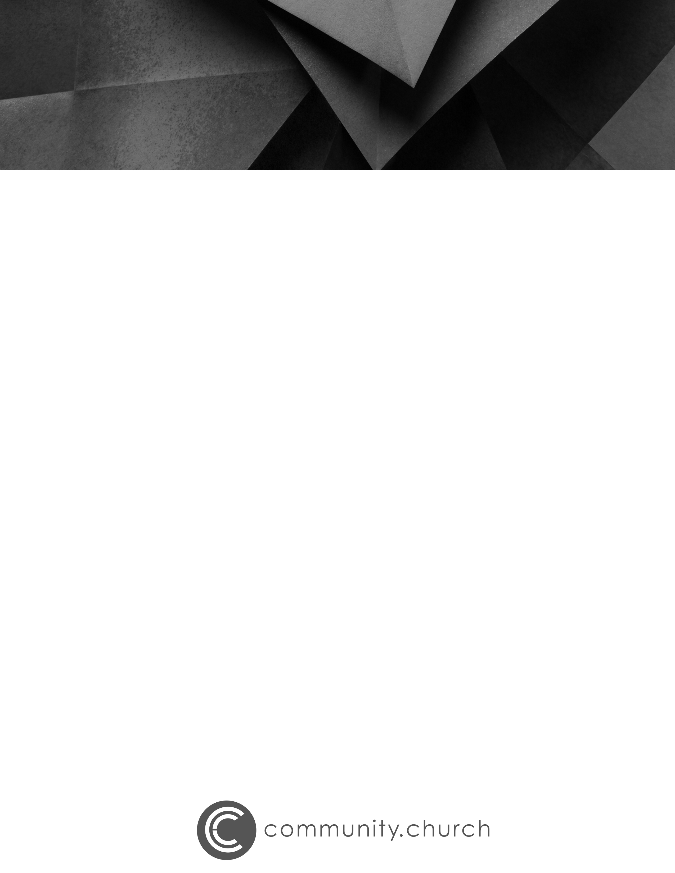
MESSAGE DISCUSSION QUESTIONS
Wild and Free
Pastor Michael Brueseke

Read Psalm 24.

Everything is God’s, which means God has everything I need and then some. How does knowing this help you to look at your life and your resources differently?

Re-read verses 3–4. How are you seeking God’s presence? What keeps you from seeking Him?

the pursuit of purpose > the pursuit of pleasure
What is God’s purpose for your life? How are you pursuing that purpose?

